Manual installation of the Visual Basic Runtime files on W7 64 bits.

Starting with satellites I would like to use software from Mike DK3WN.
The file itself was downloaded in second, getting it to work took a bit longer.

For Mike’s software written in Visual Basic 6 you will need some runtime library files.
Usually the installer will work but sometimes it won’t, in my case it didn’t work.
I had to install the ocx files manually before I had success.
The major problem was a rights issue, even in the DOS box I didn’t have enough rights to install these files.

Mike has the files needed available for download on his website.
I installed all the files I might need now or in the future.

At the end it appears to be rather simple as you can see.
It’s a Dutch Windows version but will be clear enough.

These are the files to be installed:
COMDLG32.OCX
mschrt20.ocx
mscomm32.ocx
mswinsck.ocx
richtx32.ocx
TABCTL32.OCX
I’ve put these files in a subdirectory called c:\tmp as you can see later.

The installation of the files:
Go to your command line.
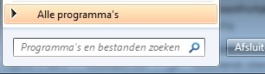

And type cmd.
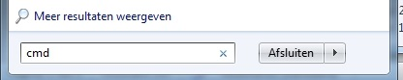

Go to the command thumbnail in the upper part of the window.
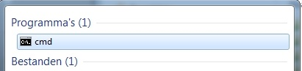

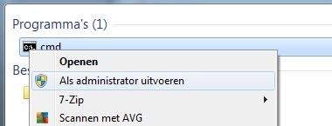
Right click on your mouse and select “Run as administrator”.

You’ll get a DOS box.
Use the command regsvr32 followed by the directory and the file you want to install.
For example regsvr32 c:\tmp\COMDLG32.OCX followed by hitting enter.
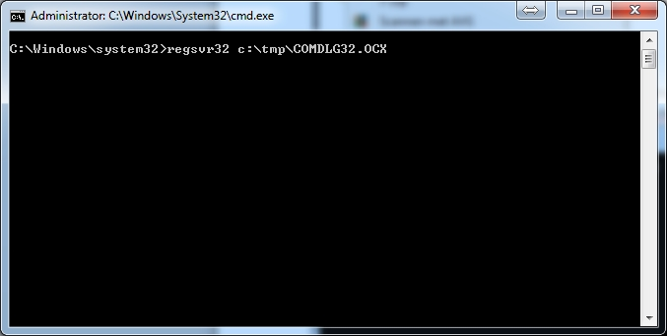

You’ll get a message that the file is successful installed.
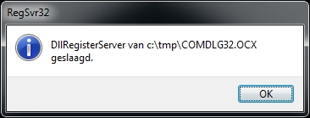

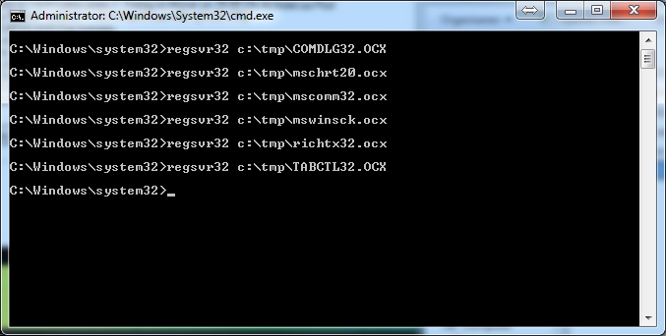
Now you can continue with the next file.
At the end you’ve installed all the ocx files and it should work!

